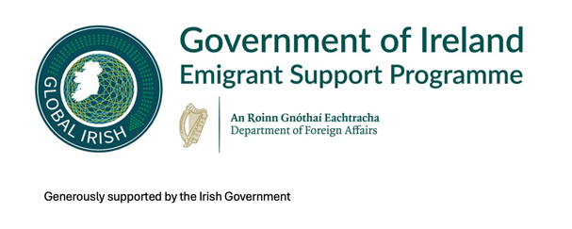
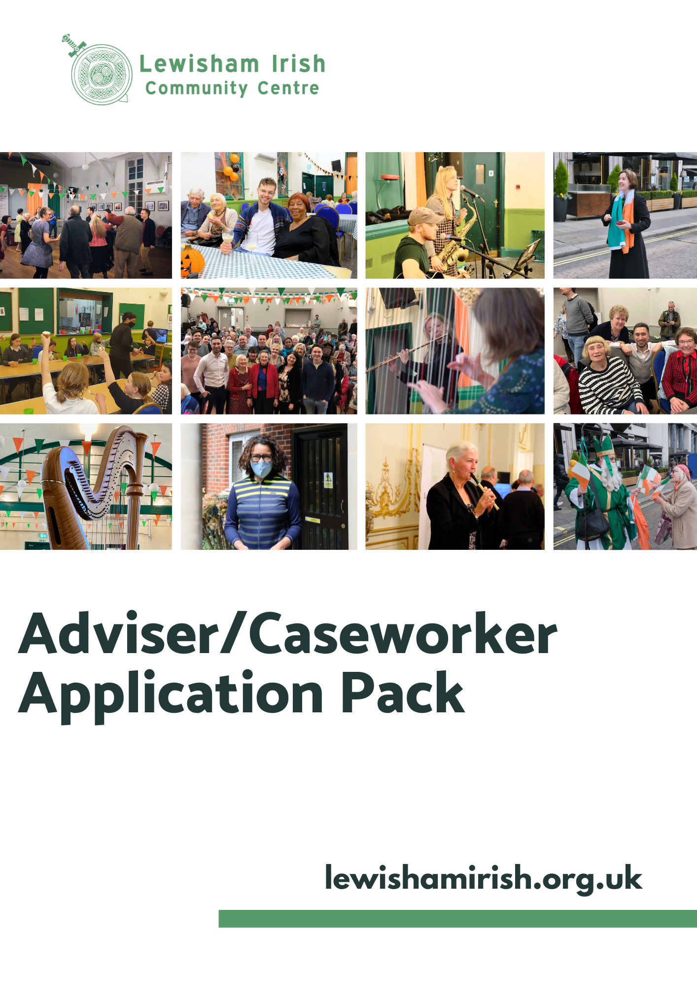
About us
Established in 1992, Lewisham Irish Community Centre is an organisation with an enduring passion for transforming the lives of the people it works with. Primarily we have been focused on the needs of Irish, Irish descent and people from the Irish Traveller community. LICC enables people to build resilience, retain independent and fulfilled lives and access the right kind of support when required.
Vision
A confident empowered Irish community
Mission
An engaged Community Centre enriching lives by providing accessible services and facilities to the local community.
Strategy
We will achieve our Vision by focusing on four key areas of delivery and growth
- Welfare of The Irish Community
- Keeping our Community Connected
- Collaboration
- Rebuilding and Sustainability

Lewisham Irish Community Centre

Adviser/caseworker – Outreach role

Job description
Adviser /caseworker - Outreach
Job Title: Outreach Advice/Caseworker - working across Lewisham, Bromley, Croydon and Lambeth.
Based: Lewisham Irish Community Centre, 2a Davenport Road, London SE6 2AZ
Fulltime 35 hours
Salary: £30,000
Reporting to: Lewisham Irish Community Centre Head of Welfare Services
Contract: Permanent subject to continued funding

Application Process
Application Deadline: Monday, 19 January 2026. Late applications will not be considered.
Interview Dates: Interviews for shortlisted candidates are scheduled to take place during the week commencing 26th January 2026
.

Purpose of the Role
The Advise/Caseworker – Outreach role has been created to broaden the reach of advice and support services, specifically extending into the boroughs of Croydon and Bromley. An essential aspect of this position involves establishing strong connections within these areas and setting up satellite services, ensuring that support is accessible to those who need it in these communities.
In this role, the Advicer will actively contribute to the Lewisham Irish Community Centre’s mission to address the needs of older Irish residents living in Lewisham, Croydon, and Bromley. The postholder will deliver outreach services, respond to enquiries, and manage casework. Their responsibilities will focus on assisting clients to access welfare benefits, improve their housing situation, and help prevent homelessness.

Duties and Responsibilities
- To provide advice to clients on a range of welfare-related issues including welfare benefits, housing, access to healthcare and supported accommodation, returning to/moving from Ireland, Irish state pensions, Irish passport and birth certificate applications.
- To support clients to discuss, access support and manage their physical and mental health issues.
- To support clients with community involvement and participation through accompanying to and arranging transport to social events and activities.
- To offer advice via a range of methods, including face-to-face, onsite and/or via home visits and outreach at third party locations.
- To act on client’s behalf by representing their interests to third parties by letter, telephone, email, or in person.
- To prepare documentation in support of mandatory reconsiderations and tribunals.
- To represent clients at tribunal hearings.
- To enable and empower clients to act for themselves wherever appropriate.
- To record and report on work carried out, via use of case-recording software and paper files, as required.
- To comply with the requirements of the Advice Quality Standard and GDPR in relation to case and file management.
- To identify own training needs in response to changes in external policies and practices.
General Responsibilities
- To attend relevant training and events as required.
- To attend staff meetings, service development and promotional activities, including some organisation-related events.
- To be aware of and adhere to organisational policies and procedures particularly those relating to equal opportunities, client confidentiality and health and safety.
- To adhere to safeguarding policies and practices.
- To carry out all administrative tasks associated with duties.
- To undertake other related tasks as and when required.
This job description is subject to an annual review as part of the organisation’s performance appraisal.
The notice period for this post is one month in writing (excluding outstanding annual leave and Time
Off in Lieu entitlement).
The post will be self-servicing, and the post holder will be responsible for the administration workload.

Person Specification

 |  | Essential | Desirable | Measured by
Education | - No specific qualifications but evidence of ongoing professional development |  |  | Application
Experience | - Minimum of one year experience of advice work, particularly welfare benefits  - Experience of casework - either paid/unpaid.  - Experience of negotiating/liaison with statutory/voluntary agencies |  |  | Application/Interview  Application/Interview  Application/Interview
Skills | - Ability to interview and assess the needs of clients in a culturally sensitive manner  - Ability to keep up to date with welfare and housing legislation  - Excellent communication skills  - Ability to record and maintain client information, write reports & produce statistics |  |  | Application  Application/Interview  Application/Interview  Application/Interview
Knowledge | - Knowledge/interest of the needs of older Irish people  - Knowledge of welfare and housing legislation  - Knowledge of statutory/voluntary sector resources available to people with complex needs  - Working knowledge of safeguarding and equal opportunities  - Knowledge of/willingness to learn about assured quality systems |  |  | Application/Interview  Application/Interview  Application/Interview  Application/Interview  Application
Personal Qualities | - A flexible and creative approach to work to meet client need  - Ability to work on own initiative and as part of a team |  |  | Application/Interview  Application/Interview
Other | - Willingness to undertake occasional evening and weekend work |  |  | Application
Got Questions?
For an informal chat, please call Kathleen Sheridan CEO on 07956509033 or email Kathleen on Manager@lewishamirish.org.uk to arrange.
To Apply
To apply please submit the following:
Your CV detailing your education and work experience and a cover letter detailing how you meet the job specification requirements. The cover letter should be no more than 2 pages
Email to - Manager@lewishamirish.org.uk
Application Deadline – Monday 19 January 5pm.

